Cultural Exploration

The Culture/Country:
INDIA

What do you know about this culture?  - the food has many spices  - one of the poorest countries in the world  - their version of Hollywood is called Bollywood  - there is a formal traditional dress females have to wear  - women have their nose pierced  - everyone is usually tanned (it is very sunny) | What do you want to know about this culture?  - traditional food recipes  - where they get their spices from  - more about Bollywood!  - why females have to dress in saris?
The flag (country, region):
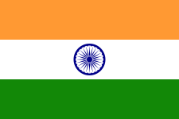
This culture/country is known for:
- Butter chicken
- Festivals
- Curry
- Ghandi
- Patriachy (men have more control than women)
- Arranged marriages
- Second most populated country in the world
- Gold jewelry on the women
- Temple etiquette
- Ghandi was born there (he challenged the British government to make India an independent country peacefully)
- cows are sacred (in Hinduism)
- many religions (Hinduism, Muslim, Sikh)
Stereotypes associated with this culture/country:
- India is a land of snake charmers?
- All educated Indians are IT techs, there are a lot of call centres in India
- Indian cuisine is only Butter chicken, curries and na’an bread
- Indians are uneducated?
- All speak hindi and have henna tattoos
Geographical Qualities:
- North of the equator
- Mountainous, deep valleys, plains
- There are jungles and deserts
- Many populous cities
- 1.25 billion people!
- Largest city was Mumbai
- New Dehli
- 3, 287, 000 km²
Customs, habits, and values:
- women shake hands with women, men shake hands with men
- many homes have prayer rooms
- eat food with fingers
- men are providers and women do cleaning and take care of children
- very religious – observe a lot of traditions
Important Arts (Music, art, film et cetera):
- Bollywood – Bride and Prejudice, Bollywood Hollywood, Slumdog Millionaire, Salam Bombay
- Traditional dances – (tribal, choreographed dances in movies)
- Music – very vibrant, girls voices are high pitched, lots of instruments
- Art – very detailed oriented, colourful - 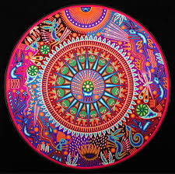 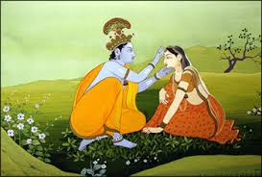
Language and Ethnicity:
- Hindi and English are the two official languages
- A very large variety of ethnic groups (Sikhs, Hindus, Muslim…)
Food:
- gulab jamun – fritters (spongy milk balls )
- momo (dumplings filled with minced meat)
- na’an bread
- butter chicken
- chicken korma
- mango lassi (yogurt based drink)
- kheer (rice pudding)

